Jenkins Sonar And Argo CD Doc

Create an ec2 instance t2.xlarge

Connect ec2 with ssh from local

Installations
Maven

sudo yum update
sudo yum install -y maven
mvn -version

Now Install open jdk 11

sudo yum install java-11-amazon-corretto-headless

Now Install Docker

sudo yum update -y
sudo yum install -y docker
sudo service docker start
sudo chkconfig docker on - This command configures the Docker service to start automatically on system boot

Overall, these commands update the system, install Docker, start the Docker service, and set it to automatically start on system boot, allowing you to work with Docker and run containerized applications on your Linux system.

Now install Jenkins

sudo wget -O /etc/yum.repos.d/jenkins.repo \
https://pkg.jenkins.io/redhat-stable/jenkins.repo
sudo rpm --import https://pkg.jenkins.io/redhat-stable/jenkins.io-2023.key
sudo yum install jenkins -y
sudo systemctl enable jenkins
sudo systemctl start jenkins

yum update -y yum.noarch

Install Node

curl -o- https://raw.githubusercontent.com/nvm-sh/nvm/v0.39.3/install.sh | bash

. ~/.nvm/nvm.sh

nvm install 16

Verification:
node -e "console.log('Running Node.js ' + process.version)"

Install Git
sudo yum install -y git

Add following things in security grp

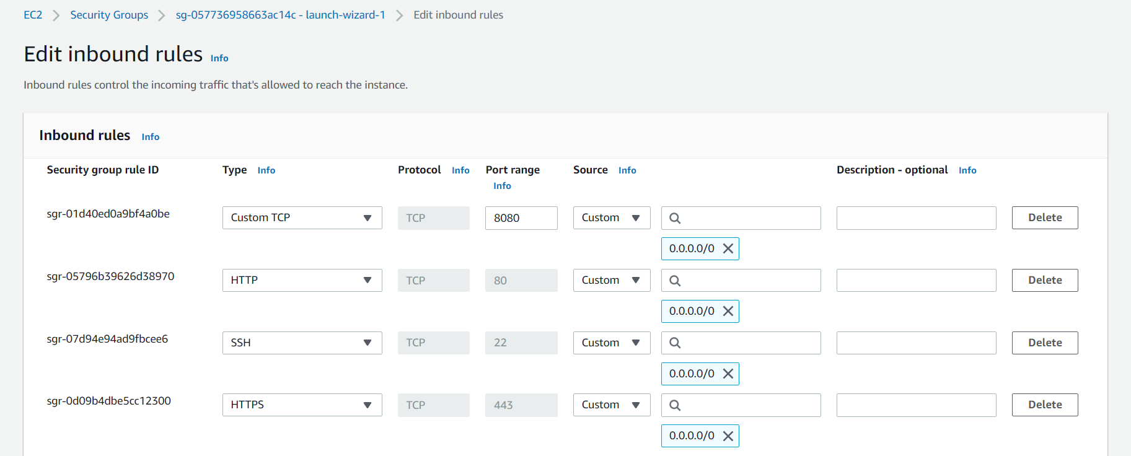

To check the status of jenkins

sudo systemctl status jenkins

After this get password from below command in jenkins

sudo cat /var/lib/jenkins/secrets/initialAdminPassword

After Jenkins installation add ssh plugin
Manage jenkins - plugin
- Available plugin - SSH Agent - install without restart
- Manage jenkins - tools- Add Maven

To integrate webhook in jenkins

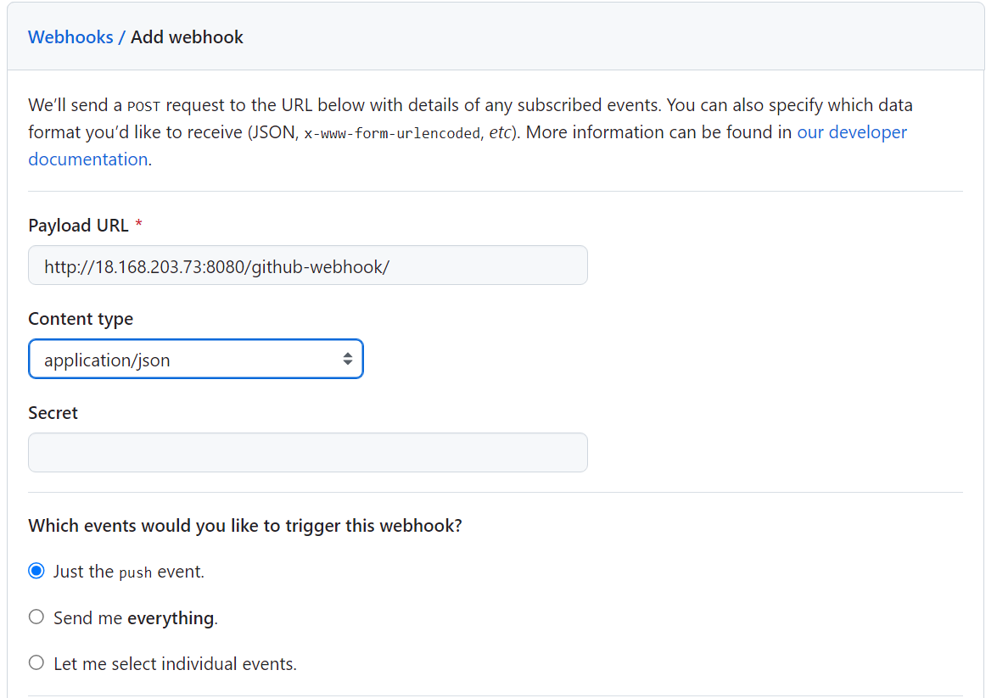

Create ssh key in jenkins server using command
ssh-keygen -t rsa -b 4096

Command to fetch public key -
cat ~/.ssh/id_rsa.pub

Command to fetch private key -
cat ~/.ssh/id_rsa

Add this public key in git hub . go to setting go to ssh key and add new key

Add private key in jenkins now
Go to jenkins - manage jenkins - credentials - Add ssh username with private key

Add docker creds - username with password
Codedecode25
DOCKER_HUB_CREDENTIAL - id

Also add this no verification which will be used during git push
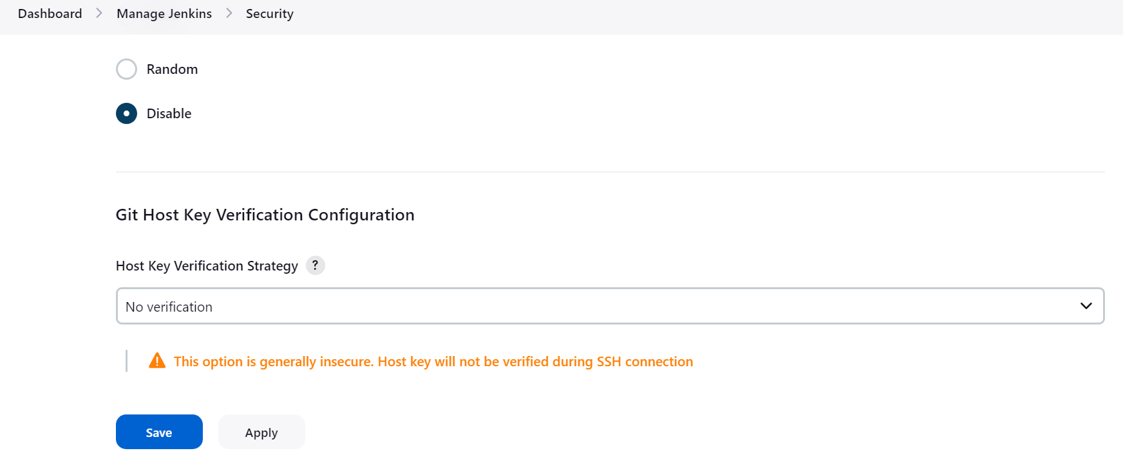

Go to jenkins home. Click new item. Click on pipeline. Copy Restaurant Service Http clone url
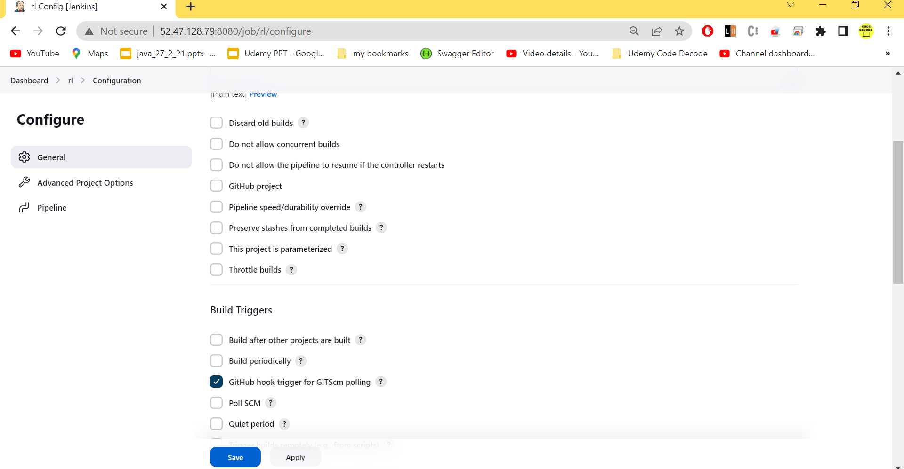

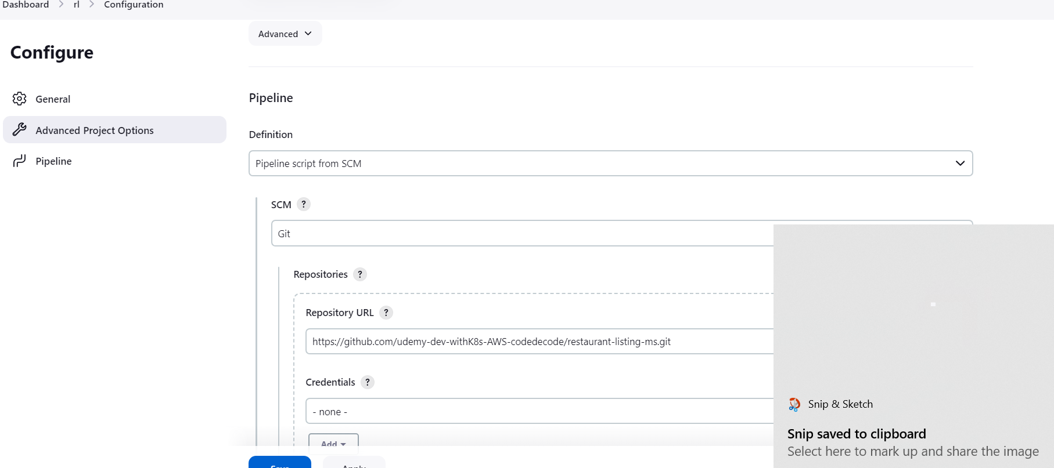

sav e n add dummy commit build automatically triggers
Nowcheck manifest file

To provide access to docker
sudo usermod -aG docker jenkins

Restart jenkins after that
sudo service jenkins restart

Sonar

Run Sonar in docker using below command
docker run -d -p 9000:9000 --name sonarqube sonarqube

To check the logs
docker logs -f sonarqube

Hit
15.188.80.32:9000 for sonar dashboard and username password will be admin

To generate token go to sonar dashboard
Click on user icon - my account - security and create new token

Quality GAtes

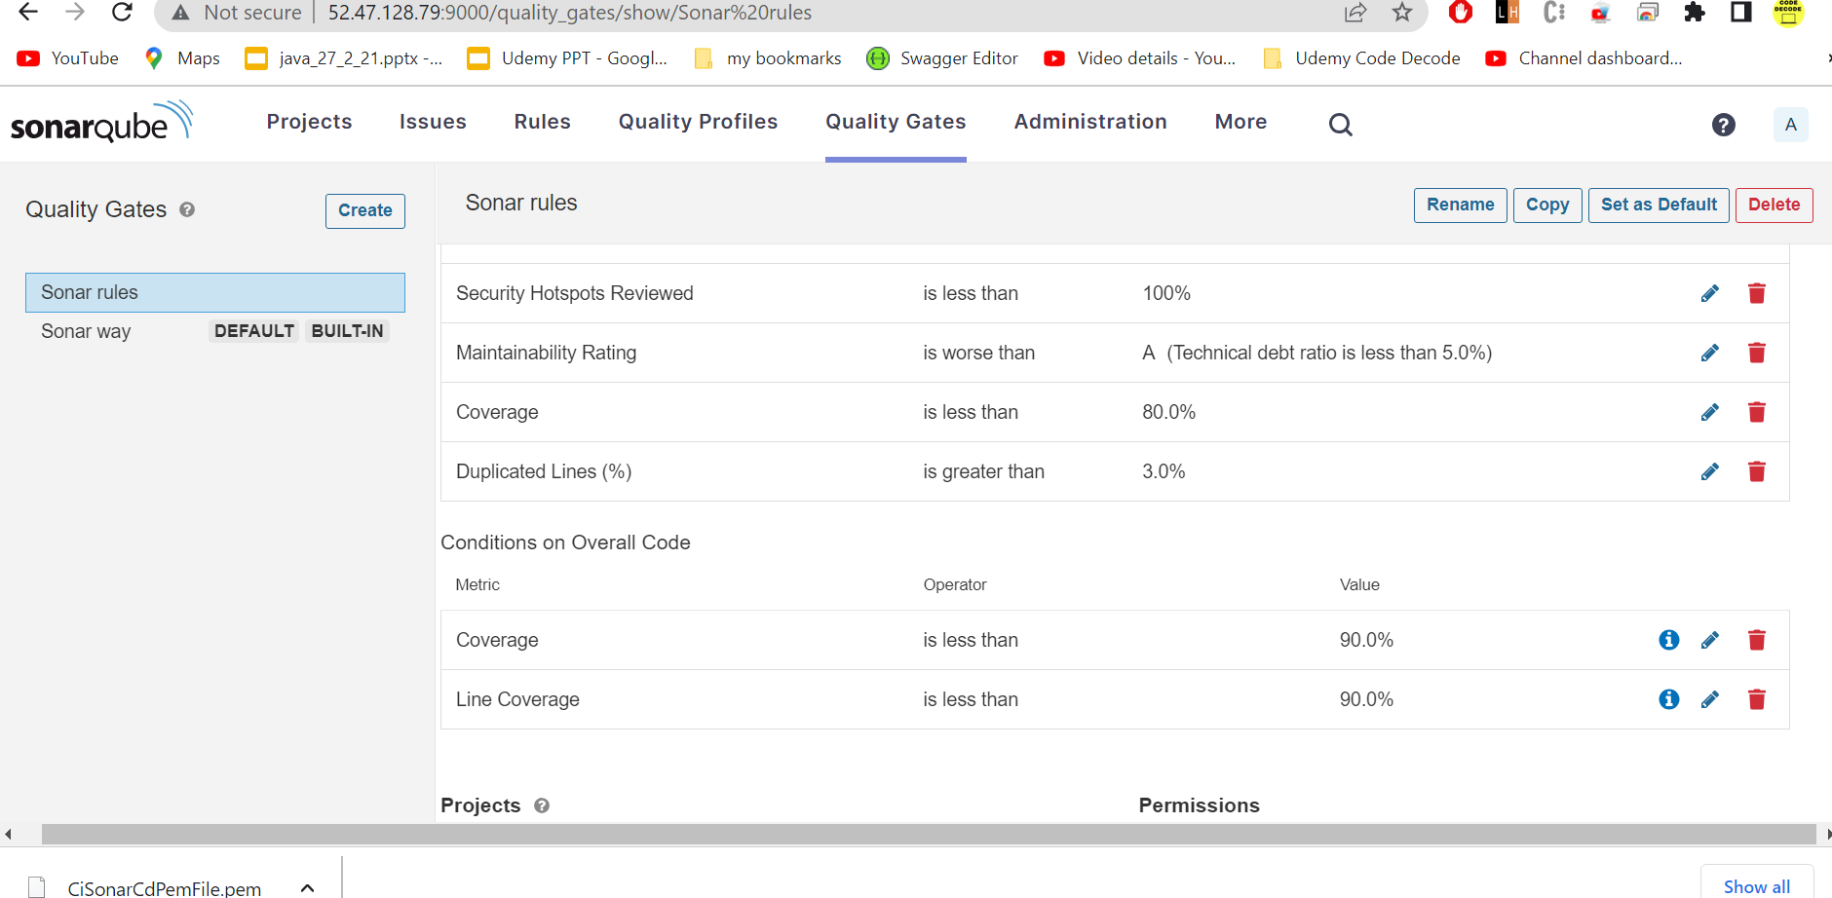

To run sonar in local n push report in sonar dashboard
mvn clean org.jacoco:jacoco-maven-plugin:prepare-agent install sonar:sonar -Dsonar.host.url=http://15.188.80.32:9000/ -Dsonar.login=squ_32789bcdadb6e4337e432d6cbc100c2a1a14fde5

Now put following dependencies in pom

<plugin>
<groupId>org.apache.maven.plugins</groupId>
<artifactId>maven-compiler-plugin</artifactId>
<configuration>
<source>1.8</source>
<target>1.8</target>
<annotationProcessorPaths>
<path>
<groupId>org.projectlombok</groupId>
<artifactId>lombok</artifactId>
<version>1.18.26</version>
</path>
<path>
<groupId>org.mapstruct</groupId>
<artifactId>mapstruct-processor</artifactId>
<version>1.4.2.Final</version>
</path>
</annotationProcessorPaths>
</configuration>
</plugin>
<plugin>
<groupId>org.sonarsource.scanner.maven</groupId>
<artifactId>sonar-maven-plugin</artifactId>
<version>3.8.0.2131</version>
</plugin>
<plugin>
<groupId>org.jacoco</groupId>
<artifactId>jacoco-maven-plugin</artifactId>
<version>0.8.8</version>
<executions>
<execution>
<id>prepare-agent</id>
<goals>
<goal>prepare-agent</goal>
</goals>
</execution>
<execution>
<id>report</id>
<goals>
<goal>report</goal>
</goals>
</execution>
</executions>
</plugin>

Add this command in properties
<sonar.exclusions>**/com/codeddecode/restaurantlisting/dto/** , **/*/com/codeddecode/restaurantlisting/entity/**/*</sonar.exclusions>

To generate token go to sonar dashboard
Click on user icon - my account - security and create new token

Where to get component key
Click on project – project setting – update key
Here you will find component key
<groupId>:<artifactId>

Run sonar using below command
mvn clean org.jacoco:jacoco-maven-plugin:prepare-agent install sonar:sonar -Dsonar.host.url=http://localhost:9000/ -Dsonar.login=squ_a44ef243148d9f75cb3248851df2d555d5342ee2

After this delryr ptpject

Argo CD

Command to install argo cd in cluster

kubectl create namespace argocd

kubectl apply -n argocd -f https://raw.githubusercontent.com/argoproj/argo-cd/stable/manifests/install.yaml

kubectl port-forward svc/argocd-server -n argocd 8080:80

To Get the password
Initial username
argocd admin initial-password -n argocd

To install argocd cli
choco install argocd-cli

Create ssh key in jenkins server using command
ssh-keygen -t rsa -b 4096

Command to fetch public key -
cat ~/.ssh/id_rsa.pub

Command to fetch private key -
cat ~/.ssh/id_rsa

To delete argocd completely
kubectl delete -n argocd -f https://raw.githubusercontent.com/argoproj/argo-cd/stable/manifests/install.yaml

If pods are in terminating state

kubectl delete pods --all -n argocd --grace-period=0 --force

Go to setting - repository - connect repo

Overall, the provided YAML describes an Argo CD "Application" resource that deploys application resources from a Git repository, with specific configuration options for the Argo CD Image Updater and synchronization behavior.

